Final Report

Stonebridge Group 2 - Two Birds, One Stonebridge

Joseph Aguilar, Eric Mueller, Jase Peeler, William Sutton

1. Executive Summary
Stonebridge Oil Solutions is seeking to better understand the effect of Saltwater Injection Wells (SWIW) on nearby production wells. There is growing concern that these injection wells are altering underground pressure and resulting in escaped water, both of which could potentially impact nearby production wells. This is not only a problem for companies owning and operating production wells, but some are worried that the underground water reservoirs may be impacted by these SWIWs.
Our research analytically evaluates this effect using a Difference-in-Differences model to determine the large scale effect of SWIWs on nearby production wells within 3km. At scale, our model finds no significant impact of SWIWs on oil and gas well production. However, in looking at individual well differences before and after the nearest SWIW was permitted, we can identify wells that may have been impacted. We recommend further analysis of these potentially impacted production wells to identify the cause of their decreased production.

2. Background & Context
Over the past two decades, the rise of horizontal hydraulic fracturing, or fracking, has transformed oil and gas production across the United States. In states like Ohio, where shale formations are rich in hydrocarbons, this technology has opened access to large reserves that were once too difficult or expensive to reach. However, this surge in production has also created new challenges, particularly in managing the large amounts of wastewater produced during the fracking process.
When shale rock is fractured to release oil and gas, significant volumes of fluid return to the surface containing brine, chemical additives, and other materials from deep underground. This wastewater must be handled and disposed of safely to prevent contamination and preserve long-term reservoir stability. The most common disposal method involves injecting this wastewater deep underground through specialized injection wells that isolate it from drinking water and other sensitive formations.
As the number of injection wells has increased, so have concerns about their impact on nearby production wells. Subsurface injection can alter underground pressure, which may affect reservoir behavior, reduce production efficiency, or cause fluids to migrate into unintended areas. These issues create both environmental and operational challenges for oilfield service companies working to maintain productivity while ensuring safety and compliance with regulations.
This project examines how injection well activity may influence oil and gas production across Ohio. Using spatial and production data from the Ohio Department of Natural Resources, we investigate whether injection operations are associated with measurable changes in nearby production wells. The analysis also explores how these effects vary with distance, well type, and other factors.
The client, Stonebridge Oilfield Solutions, plans to use the findings to improve their field management and risk mitigation strategies. The results will help them:
- Detect possible hydraulic communication between injection and production wells
- Identify production wells that may be affected by pressure changes from injection activity
- Prioritize wells for plugging or monitoring to protect reservoir integrity and prevent environmental damage
Through this work, Stonebridge aims to better understand the connections between injection and production wells, reduce environmental risk, and support more sustainable oil and gas operations in Ohio.

3. Methods
We began our process by collecting data from the Ohio Department of Natural Resources (ODNR). Their website contains annual production data for all traditional vertical oil and gas producing wells within the state since 2010, and it has quarterly reports on all horizontal oil and gas producing wells since 2020. We downloaded and aggregated this data to use in analyzing the production of different wells. The website also contains PDF data from before 2010, but we opted to use the more accessible files, focusing our research on 2010 through the present.
The ODNR website also contains a Well Database. Within this, we found a Permit and Plug list containing records of every well that was given a permit or plugged since 1998. This dataset included well locations, well classifications, owner information, and dates on which the permits were issued. This was helpful both for understanding well locations and for identifying which wells were SWIW. We also obtained a list of well information, further detailing well locations and owner information. This dataset only contained currently active wells, and helped us add to the list of wells we obtained from the permit/plug list.
After exploring the collected data, we went through the process of cleaning it to prepare it for use in our analysis. We concatenated all of the quarterly and annual production reports. In doing so, we noticed that there were many missing values and some extremely high outliers. For simplicity, and because we had so much data, we opted to exclude wells with missing production data and wells with outlier production. We examined the distribution of annual production for all three of oil, gas, and brine. We found that 90% of well production values were under 466 Bbls for oil, under 5852 Mcf for gas, and under 1120 Bbls for brine.
After examining the production data, we looked into the permit and plug dataset, which importantly contained the columns necessary to identify SWIW. We found that both PROP_WLTYPE and PROP_WELL_CLASS contained well type distinctions, but PROP_WELL_CLASS contained many missing values, so we used PROP_WLTYPE to identify SWIW. We also noticed that 1706 wells had missing values for latitude and longitude, so we removed those wells from the dataset. Lastly, we examined the Well Information dataset, which contained well latitudes and longitudes for additional wells. We found that 1669 wells had missing latitudes and longitudes in this dataset, so we excluded those.
Using the latitudes and longitudes from the Permit/Plug dataset and the Well Information dataset, we were able to identify wells as either production wells or SWIW, and we plotted their locations in the chart below.
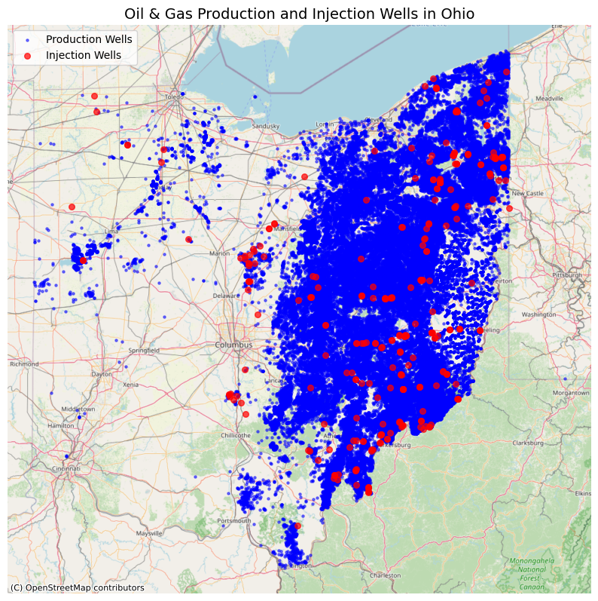
We knew that we wanted to analyze the impact of SWIWs on nearby production wells. To identify which production wells are near SWIWs, we needed to calculate the distance between each well. Using cartesian projections of latitude and longitude, we calculated the distance between each well and minimized the distance between each production well and the set of SWIWs. This left us with a dataset containing each production well, the associated nearest SWIW, and the distance between them. We then plotted these distances in the charts below.
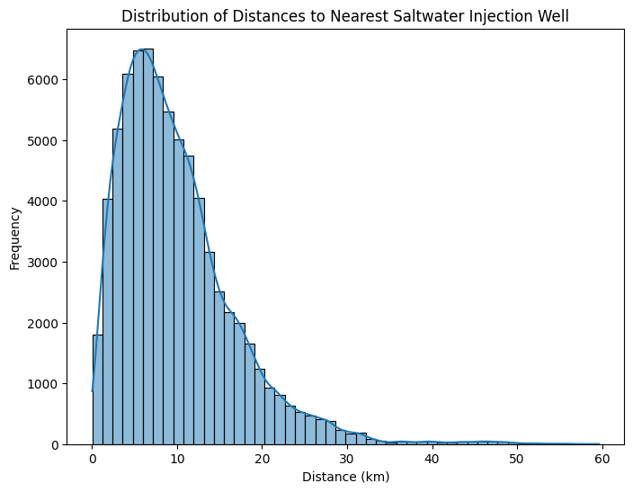
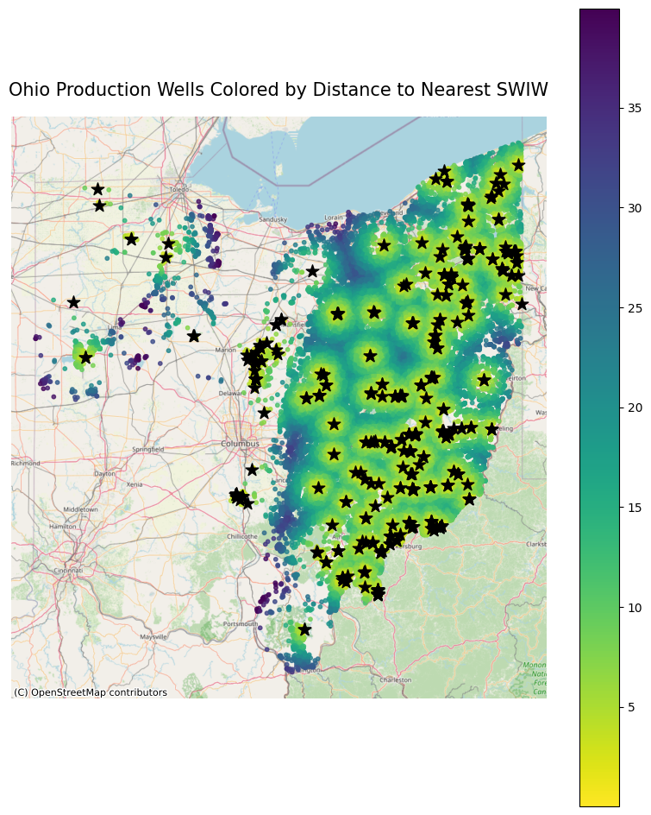
With this data, we wanted to build a model that would help us understand how production wells are affected by nearby SWIW. Our idea was to build a model that compares each well's production data before and after the nearest SWIW is drilled. To do this, we built a Difference in Differences (DiD) model. This model structure uses Ordinary Least Squares (OLS) regression techniques with fixed effects for each entity and time period to isolate the effect of a particular treatment that is applied to each entity. In our case, we use fixed effects for each production well and each year, and we use the date the nearest SWIW is permitted as the treatment. However, we want to go beyond just measuring the effect of this treatment. We also want to see if the treatment effect is larger on wells that are closer to the nearest SWIW. Thus, we use an interaction factor between distance to nearest SWIW and our treatment effect. This gives us the following overall model structure:
$y_{it}​=β_{0}​+β_{1}​post_{it}​+β_{2}log(inv_dist_{i}​)+β_{3}​(post_{it}​⋅log(inv_dist_{i}))+α_{i}​+λ_{t}​+ε_{it}$
where $y_{it}$ represents oil/gas production for well $i$ in year $t$, $post_{it}$ is the binary variable representing whether the observation is before or after the nearest SWIW is drilled, $log(inv_dist_{i})$ represents the log inverse distance of the production well to the nearest SWIW, $post_{it}​⋅log(inv_dist_{i}))$ represents the DiD interaction effect between our two variables, $α_{i}$ represents the fixed effect for well $i$, $λ_{t}$ represents the fixed effect for year $t$, and $ε_{it}$ represents random error. $β_{0}$, $β_{1}$, $β_{2}$, and $β_{3}$ are the learned model coefficients, which we test the significance of.
Though the model is complex, the most important part is $β_{3}​(post_{it}​⋅log(inv_dist_{i}))$. We want to find whether $β_{3}$ is significantly different from 0, which determines whether we can conclude that there is a significant difference in the production of wells close to the nearest SWIW before and after that SWIW is drilled.
For these DiD models, we limited our dataset to only include wells that were within 3 km of the nearest SWIW, operating under the assumption that wells farther away would not see any impact. We also limited our dataset to only include wells that had production both before and after the nearest SWIW was permitted, which helped avoid bias from wells that came into production after the SWIW was drilled or from wells that were decommissioned before the SWIW was drilled. Lastly, we limited our dataset to only include wells with a mean yearly oil production under 200 Bbls and a mean yearly gas production of under 1000 Mcf. This filtered down to roughly the bottom half of producing wells, as we felt that these smaller wells would be most susceptible to damage from a SWIW.
We trained one DiD model for oil production and one model for gas production, the results of which can be seen in the Findings section below. However, splitting each well's production by whether it was before or after the nearest SWIW was permitted is not necessarily the best way to test whether SWIWs affect production wells. Because SWIW will likely not impact production wells as soon as they are permitted, we built another set of DiD models that replace the $post_{it}$ term with a $post_lag_{it}$ term. Instead of splitting the production data by whether or not it is after the nearest SWIW is permitted, we split the production data by whether or not it is $x$ years after the nearest SWIW is permitted.
To find the best number of years to use for $x$, we performed a lag analysis. Using the same set of well production data mentioned above, we used production data from $x$ years ago to predict current year production using simple linear regression. As is expected, we found that the strongest correlation was between data from 1 year ago and current data, with the correlation decreasing as we increase $x$.
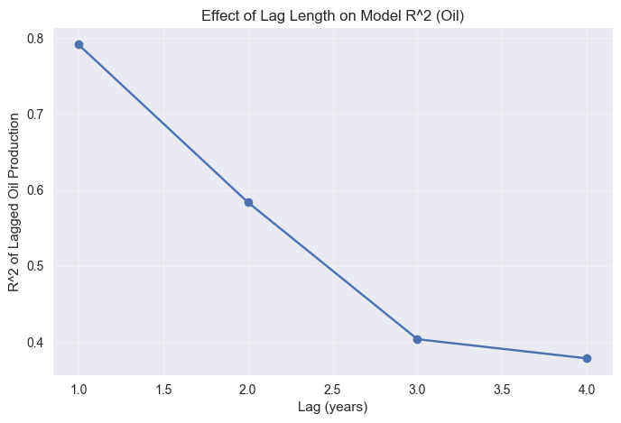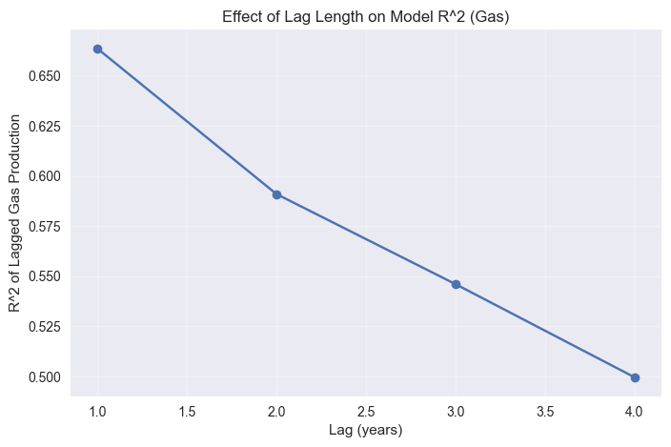
For oil, there is a steep drop off in $R^{2}$ when we use data from 3 years or earlier. This means that the production data of a well is not as highly correlated with the production data of that same well 3 years ago. Thus, if we used a lag of 3 or more in our DiD model, it would struggle to differentiate the variance due to time from the variance due to the SWIW being drilled. As such, we decided that we will build DiD models with 0, 1, and 2 years of lag from the SWIW being permitted.

4. Findings
Out of the 6 models we created, only one ended up with significant results. We found that only the oil production model with 0 years of lag had significant results, but even those were not as significant as we'd hoped. The overall model was predictive. However, only $β_{2}$, the coefficient for inverse log distance, contributed significantly to the model. Thus, the only conclusion we can draw is that since the coefficient was negative, wells nearer to SWIWs at the time that SWIWs are permitted have lower production. This does not mean that SWIWs affect nearby well production. Instead, it indicates that SWIW may be drilled intentionally in areas where oil production is lower.
For all 6 models, $β_{3}$ did not have a significant effect, indicating that our difference in difference was not significant for either oil production or gas production. We do not have sufficient evidence to conclude that SWIWs have any effect on nearby vertical production wells within two years of being permitted. That is not to say that there is no effect, as this model is not robust enough to make those conclusions, but we have not found a significant effect.
We also created visualizations to help see the differences in each considered well's production before and after the nearest SWIW was permitted (or before and after 1-2 years later than the nearest SWIW was permitted). First, we created a graph that plots the difference in production for each individual well. Red dots represent wells that gain production, while blue dots indicate wells that lost production. These charts can be seen in figures 1-4 of the appendix, and they can be recreated to be interactive using the SWIW Proximity and Production Analysis notebook in our GitHub. In all four plots, we see more wells with a decrease in production after the nearest SWIW was drilled, but very few wells exhibit large changes in oil or gas production in either the immediate plot or the lagged plot.
After looking at individual well changes, we wanted to graphically examine the overall trend of well production as it relates to the time before and after the nearest SWIW was permitted. To do so, we calculated Well Relative Production, a measure of how productive a well was in a certain year relative to its overall production, and we plotted that against Relative Time, the time before (negative) or after (positive) the nearest SWIW was drilled. The resulting plots can be seen in figures 5 and 6 in the appendix.
From the oil relative plot, we see a clear downward trend in oil production before and after the nearest SWIW is permitted. Interestingly, the downward trend begins before the SWIW permit date, indicating that the trend may not be directly related to the SWIW's effect on production. This tracks with what we learned from our model. The same conclusion can be reached from the gas relative plot, albeit at a smaller scale.

5. Recommendations
Our goal was to identify whether water injected into SWIWs was escaping and impacting nearby production wells. In considering only wells within 3km of the nearest SWIWs, we found no evidence to suggest that SWIWs have a negative effect on production, at least at scale. However, our visualizations show that there are wells that have less production after the nearest SWIW was permitted, and there are other wells that have less production two years after the nearest SWIW was permitted. Thus, our recommendation is two-fold.
First, we recommend against using this analysis as proof that SWIWs do not have an impact on production wells. While we found, at scale, that there is no evidence of a negative effect on production, our dataset focuses on a specific subset of wells that had production data both before and after our split date, and it only looks two years into the future. We feel confident that within our sample of wells, there is no large-scale impact of SWIW on production, but that cannot be generalized to all wells in Ohio.
Second, we recommend further investigation of the wells that experienced a downturn in production either immediately after the SWIW was permitted or two years after the nearest SWIW was permitted. Because the trends shown in our line plot indicate that production generally decreased after SWIW were permitted, but our model did not find evidence of this at scale, it is likely that some of the wells that did experience a downturn in production were impacted in some way by SWIW, but this didn't happen for enough wells to make the result significant. Further analysis of the wells identified by the darkest blue dots in our plots may reveal wells that have been impacted by SWIW.

6. Limitations & Next Steps
The biggest limitations of this research were related to data access. Originally, one of our goals was to analyze where the water injected into SWIW was coming from and understand why so much water is being injected in Ohio. To do so, we needed information on where the brine was coming from. We contacted ODNR to obtain Form 13 brine hauling logs, which would have provided critical information on brine transport and disposal within Ohio and strengthen the linkage between production and injection activity. After multiple follow-up emails, we never received a response.
We were also interested in understanding how injection patterns in Ohio compared to neighboring states. We were able to obtain well production data from Pennsylvania and West Virginia, but we were not able to find any datasets with well classifications, and thus we could not identify the locations or production data for SWIW. We reached out to each state's Department of Environmental Protection, but we were unable to gain access to the necessary data to move forward with this sub-analysis.
Within our Difference in Difference model, we were also limited by computational complexity. Because of the large number of wells, we were not able to run a model using all of the data. We limited our dataset to only include wells under 3km from the nearest SWIW to fit the computational power we had available. Future work should consider the feasibility of changing the structure of the model to accommodate the full set of wells, as doing so may result in a different conclusion.
Our model is also not robust to all wells within 3km. To simplify and clarify the model as much as possible, we filter out all wells that either have no production before the nearest SWIW is drilled or all wells that have no production after the nearest SWIW is permitted. Our theory is that wells impacted by SWIW will experience a decrease in overall oil and gas production, which is what we aimed to find with our model. However, because we are filtering out wells with no production afterwards, we fail to account for wells that experience a catastrophic effect from SWIW leakage and decide to cease production entirely. A future model should explore wells that stop production entirely some time period after a nearby SWIW is permitted.

Appendix
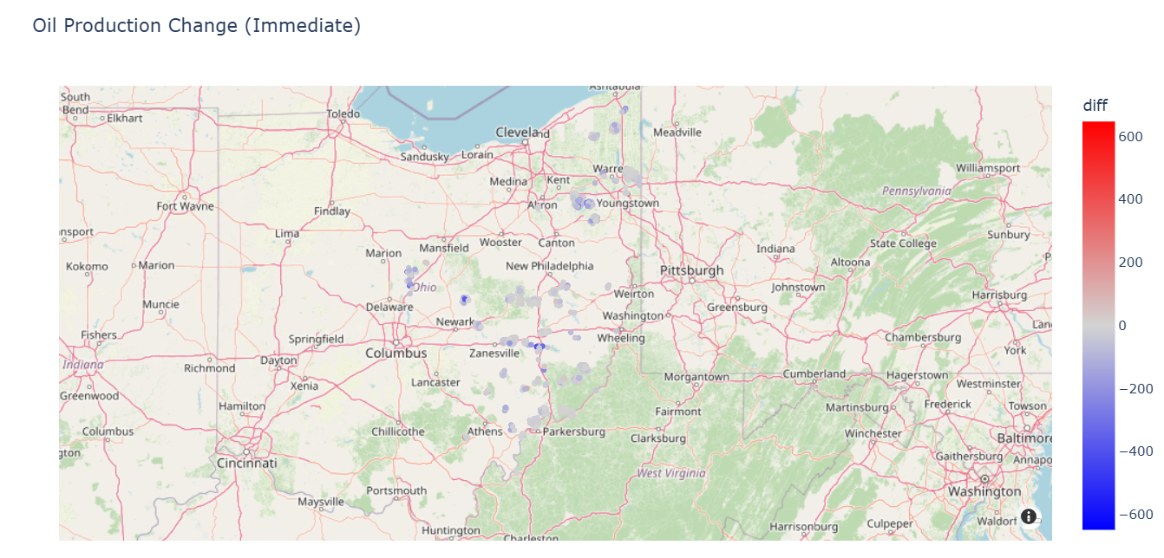
Figure 1 - Oil production change before and after the nearest SWIW is permitted

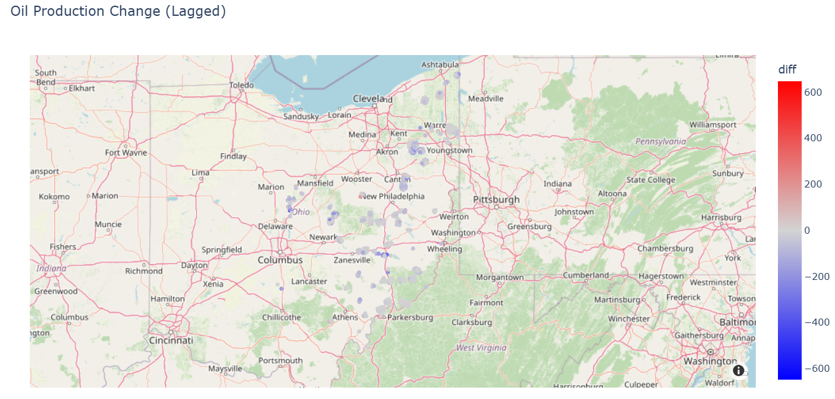
Figure 2 - Oil production change before and after the nearest SWIW is permitted, lagged by 2 years

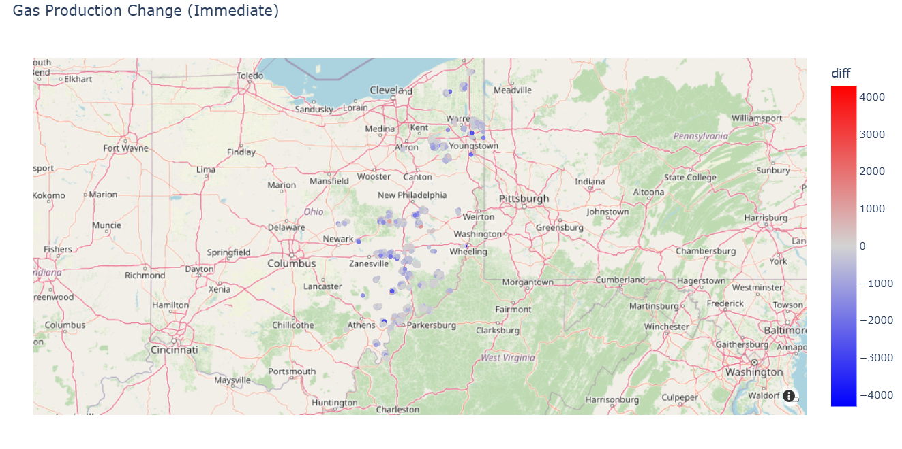
Figure 3 - Gas production change before and after the nearest SWIW is permitted

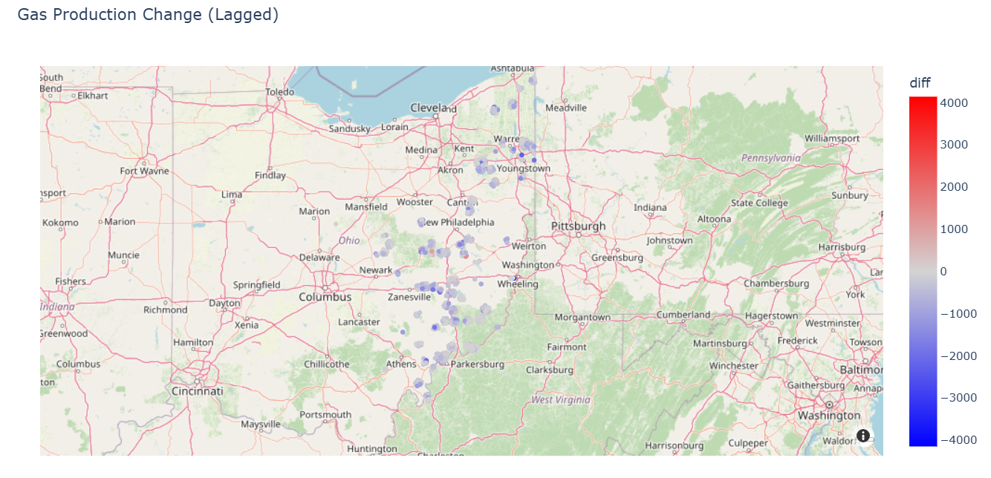
Figure 4 - Gas production change before and after the nearest SWIW is permitted, lagged by 2 years

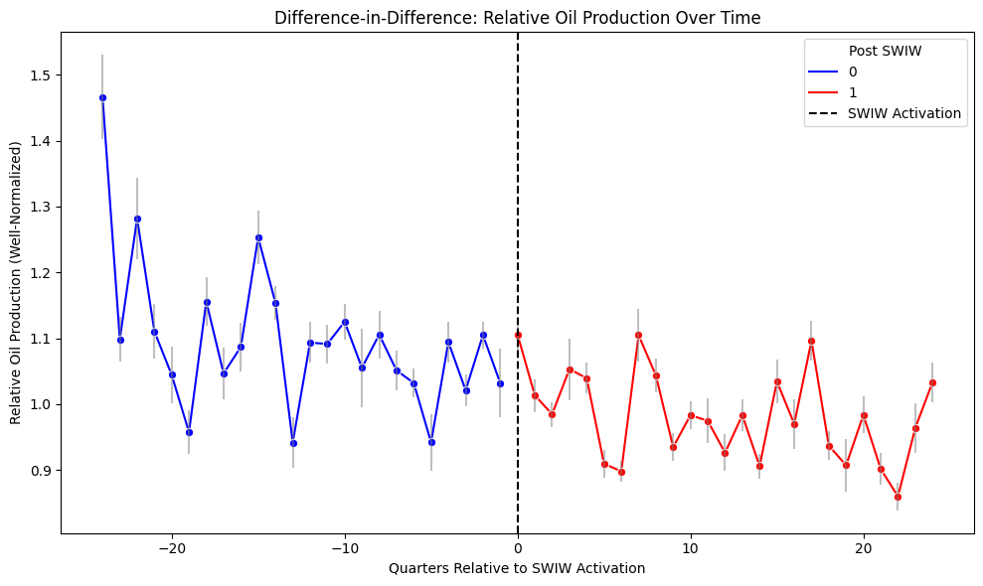
Figure 5 - Well Relative Oil Production plotted against Relative Time

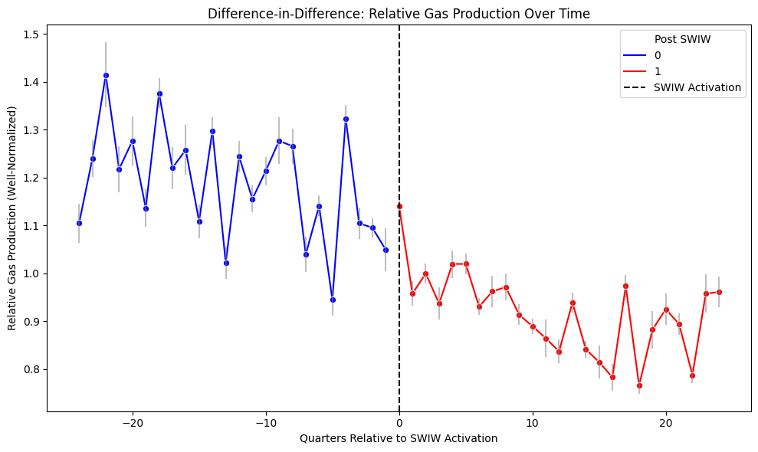
Figure 6 - Well Relative Gas Production plotted against Relative Time

